***PROJECT***

***DOCUMENTATION***

***ANALYSE THE TABLEAU HR SCORECARD: MEASURING SUCCESS IN TALENT MANAGEMENT***

INTRODUCTION

**Overview:**

**The Tableau HR Scorecard is a framework designed to measure and evaluate the success of talent management strategies within an organization. It provides a way for HR professionals and business leaders to track and analyse key performance indicators (KPIs) related to workforce planning, recruitment, retention, and development.**

Measuring the success of a talent management strategy requires a well-defined roadmap that goes beyond mere numbers. This section delves into the essential factors that contribute to accurately defining success in the context of talent man

A successful talent management strategy begins with setting clear and achievable objectives. These objectives should align with the organization’s overall mission, vision, and business goals. Defining these objectives provides a foundation for evaluating whether the strategy is on track and yielding the desired outcomes.

**Purpose:**

A talent management dashboard is a visual tool that helps you monitor and improve the performance, engagement, and development of your employees. It can help you identify strengths, gaps, and opportunities in your talent strategy, as well as align your actions with your business goals. In this article, you will learn how to create a talent management dashboard that is relevant, actionable, and user-friendly.

PROBLEM DEFINITION AND DESIGN THINKING **Empathy Map:**

Creating empathy with your users is one of the most important things you can do from both a business and a user experience perspective. Understanding the motivations, frustrations, and actions of your principal user is critical to targeting them effectively and providing sustainable solutions for their problems. Creating empathy, while not a trivial task, is easiest to accomplish via creating an empathy map.

 An empathy map is a template that organizes a user’s behaviours and feelings to create a sense of empathy between the user and your team. The empathy map represents a principal user and helps teams better understand their motivations, concerns, and user experience.

 There are **four quadrants to a traditional empathy map**. These are: Does, Thinks, Says, and Feels. These quadrants will all ask unique questions about how you can analyse the perspective of the user and what they accomplish in their daily use. These can be completed in any order as long as they all take each other into consideration and are not chronological.

**Empathy map for Tableau HR Scorecard:**

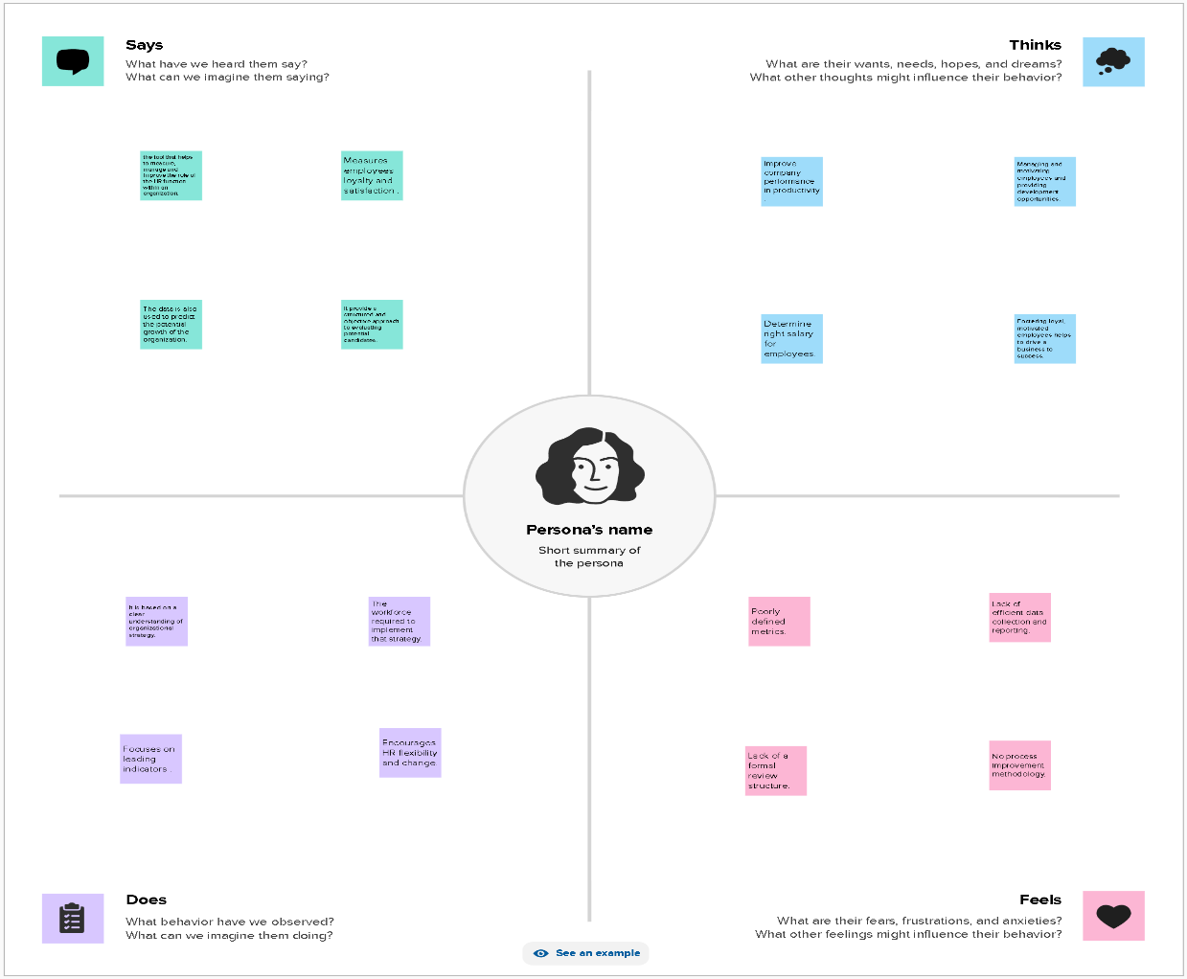

**Ideation and Brainstorming Map:**

Ideation is the process of forming ideas from conception to implementation, most often in a business setting. Ideation is expressed via graphical, written, or verbal methods, and arises from past or present knowledge, influences, opinions, experiences, and personal convictions.

Brainstorming is a group problem-solving method that involves the spontaneous contribution of creative ideas and solutions. This technique requires intensive, freewheeling discussion in which every member of the group is encouraged to think aloud and suggest as many ideas as possible based on their diverse knowledge.

Brainstorming combines an informal approach to problem-solving with lateral thinking, which is a method for developing new concepts to solve problems by looking at them in innovative ways. Some of these ideas can be built into original, creative solutions to a problem, while others can generate additional ideas.

Common methods of brainstorming include mind mapping, which involves creating a diagram with a goal or key concept in the centre with branches showing subtopics and related ideas; writing down the steps needed to get from Point A to Point B; "teleporting" yourself to a different time and place; putting yourself in other people’s shoes to imagine how they might solve a problem; and "super storming," or using a hypothetical superpower such as X-ray vision to solve a problem.

**Ideation And Brain storming for Tableau HR Scorecard:**

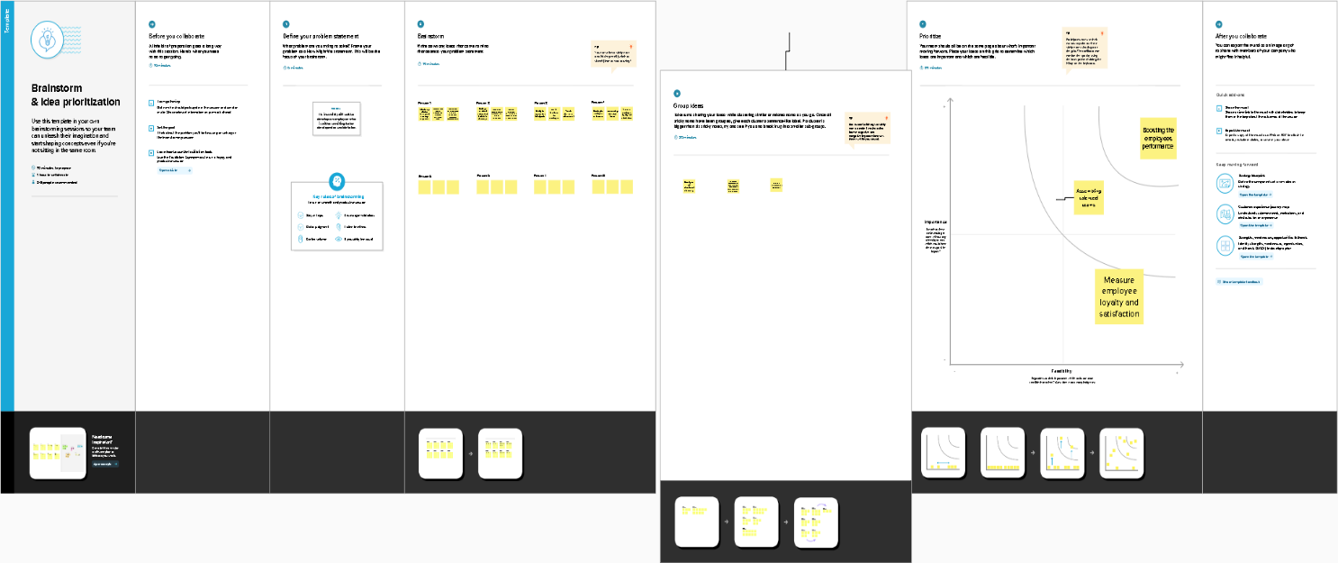

**RESULT**

**Output of my project:**

* Gives structure to the strategy
* Improve performance reporting
* Makes it easier to communicate the strategy
* Connect every HR employee to organizational goals.

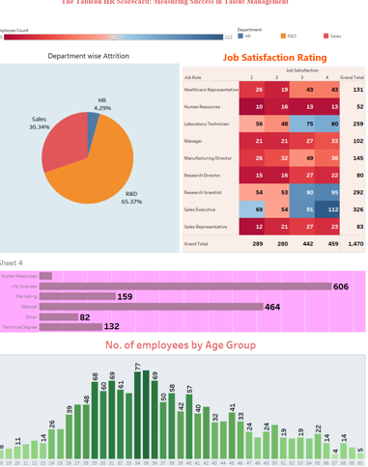

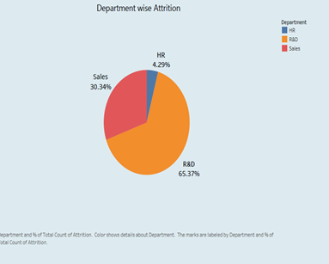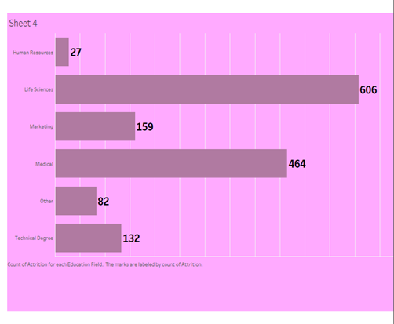

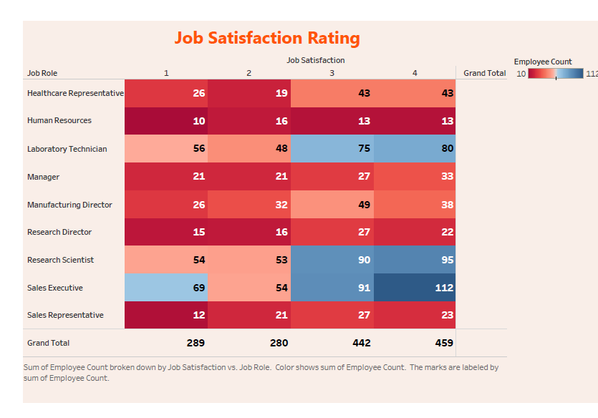

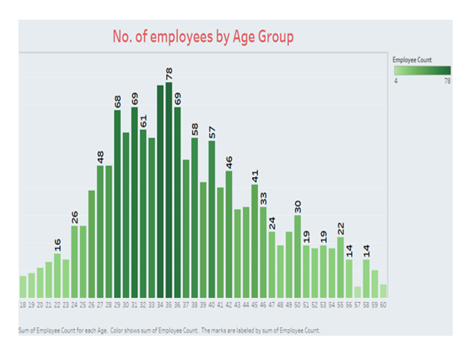

***ADVANTAGES AND DISADVANTAGES***

**Advantages:**

* Help in ascertaining the right person is deployed in the right position.
* Contributes in retaining their top talent.
* Better hiring by hiring assessments
* Helps in understanding employees better and shaping their future.
* Promotes effective communications across different disciplines.

**Disadvantages:**

* + The implementation of talent management program could be expensive in terms of time.
  + Lack of support from line managers can impede the level of commitment from employees.
  + A core drawback of talent management is, it can contribute between HR and management by not reaching to proper agreement or consensus.

***APPLICATIONS:***

The solution can be applied in

* + - Selection and recruiting
    - Employee engagement
    - Performance evaluation
    - Succession planning
    - Inclusion and diversity

***CONCLUSIONS:***

Our project title is “***THE TABLEAU HR SCORECARD: MEASURING SUCCESS IN TALENT MANAGEMENT”***. I am Sharmi S (team leader) and my team members are Bavithra SV, Abisha Joselin J, Ajeesha AS. Our first task is Empathy Map. We done this with the help of Mural App and with the ideas of myself and team members. Our next task is Brainstorm, we done this with the help of Mural App. It is a group solving method and as a group we have done this by providing solution to the problems. Third task is Dataset. We are provided with 1CSV file regarding measuring success talent management. Installing tableau on lap top. Next step is data visualisation. The number of unique visualizations that can be created with a given dataset. Some common types of visualizations that can be used to analyse The Tableau HR Scorecard: Measuring Success in Talent Management include heat map, bar charts, donut charts, pie chart, lollipop chart etc. These visualizations are used to measure success in talent management. Once we created views on different sheet in tableau, we pull them into a dashboard. Like wise we done story too. After creating story and dashboard we published it into a tableau public and downloaded it as a PDF. Next we write HTML program, connected the embedded code of both story and dashboard in the HTML program and run it and save it in a computer. Thus we completed our project.

***FUTURE SCOPE:***

HR Analytics and company strategy will merge more seamlessly in the future. Another development that will influence the direction of HR analytics is real-time analytics. A significant trend in HR analytics will be predictive analytics in the future. Ethics and data privacy will be given more weight as HR analytics develops. The integration of HR Analytics with other technologies, like AI, machine learning, and NLP, will increase in the future. By automating routine operations like data gathering, data cleansing, and report preparation, automation is already revolutionising HR Analytics. Professionals in HR Analytics will be able to concentrate on more challenging activities like data analysis, modelling, and strategic decision-making as a result. Overall, developing technologies and trends will make it possible for businesses to acquire deeper insights into their personnel and make decisions that will improve business outcomes.

***DOCUMENTATION BY***

***SHARMI S***

***BAVITHRA SV***

***ABISHA JOSELIN J***

***AJEESHA AS***